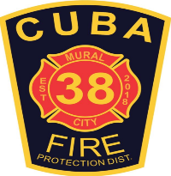
Cuba Community Fire Protection District
PO Box 511, 600 S Franklin Ave, Cuba, MO 65453
573-885-3366 | 573-885-0256Fax |www.cubamofire.com
Food Truck Permit Application
Applicants are to fill out top section. A safety inspection of your business will be conducted. Any violations must be corrected before any business can open. The Cuba Fire Protection District has adopted and follows the 2018 IBC Building and Fire Codes. Permit fees must be paid at the time the application is submitted. Any questions please contact the Fire Marshal.

Date of Application:_______________

Physical Address:____________________________________________ Business Name:________________________________________________

Business Owner Name:____________________________Business OwnerPhone:__________________Email:_______________________________

Property Owner Name:__________________________ Property Owner Phone:___________________Email:_______________________________

Cuba City Limits: Yes / No

** Certificate of occupancy is vaid for 1 year and is not bound to a specific address. The permit must be displayed and visible at all times.

Signature of Owner

Wheel Chocks: _______ Fire Extinguisher:________ 10’ Seperation:_________ Geneator 5’ from Vehicle:________ Not blocking Fire Lane:_______

Cylinders upright and secured:_______ No Flammable liquids stored inside:_______ Fire Suppression Hood:________

Approved By:___________________________________ Title:______________________________ Permit Fee:______________________________

Date Issued:_____________________________ Permit Number:____________________________

Check #___________________ Date:__________________________ Received By:_________________________________

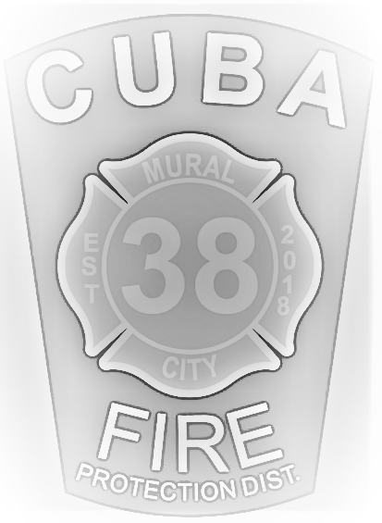
FOOD TRUCK REQUIREMENTS

These are the Fire Code requirements for Food Trucks. Chapter 3 Section 319

- An occupancy permit shall be required by the Cuba Fire Protection District. The permit is valid for 1 year and is not bound to a specific address. The permit must be displayed and visible at all times. 319.2
- Wheel Chocks shall be used to prevent mobile and temporary cooking operations from moving.
- A Minimum on one 2A:10ABC fire extinguisher shall be provided when a generator or other fuel fire appliance is used, wood or charcoal is used, or electric cooking is performed. 906.4
- Mobile cooking operations shall be separated from buildings or structures, combustible materials, vehicles, and other cooking operations by a minimum of 10’.
- Mobile or temporary cooking operations shall not block fire department access roads, fire lanes, hydrants, or other fire protection devises.
- Portable generators shall be positioned so that the exhaust is at least 5’ in any direction away from any openings, air intakes, means of egress, or part of the building or vehicle.
- Flammable liquids shall not be stored inside of the temporary cooking areas.
- Cylinders shall be secured in an upright position. 319.8.2
- Deep fat fryers or other appliances having combustible liquids heated by LP gas or electricity shall be protected by an approved hood fire suppression system. 319.3- 904.12

Please contact the Fire Marshal with any questions at Cubafd@gmail.com or 573-885-3366

