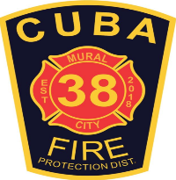
Cuba Community Fire Protection District
PO Box 511, 600 S Franklin Ave, Cuba, MO 65453
573-885-3366 | 573-885-0256Fax |www.cubamofire.com
Fireworks Permit Application
Applicants are to fill out top section. A safety inspection of your business will be conducted. Any violations must be corrected before any business can open. The Cuba Fire Protection District has adopted and follows the same requirements as the State of Missouri. Permit fees must be paid at the time the application is submitted. Any questions please contact the Fire Marshal.

Date of Application:_______________

Physical Address:____________________________________________ Business Name:________________________________________________

Business Owner Name:____________________________Business OwnerPhone:__________________Email:_______________________________

Property Owner Name:__________________________ Property Owner Phone:___________________Email:_______________________________

Insurance 1,000,000.00 Liability: YES / NO (attach copy) Tent Material:__________ Width:____________ Length:_____________

Cuba City Limits:Yes / No Fire Extinguisher: Yes / No Emergency Lighting: Yes / No Exit Lights: Yes / No

** Certificate of occupancy is vaid from June 20 through July 10. Any extension must be approved by the Fire Marshal.

Signature of Owner

Approved By:___________________________________ Title:______________________________ Permit Fee:______________________________

Date Issued:_____________________________ Permit Number:____________________________

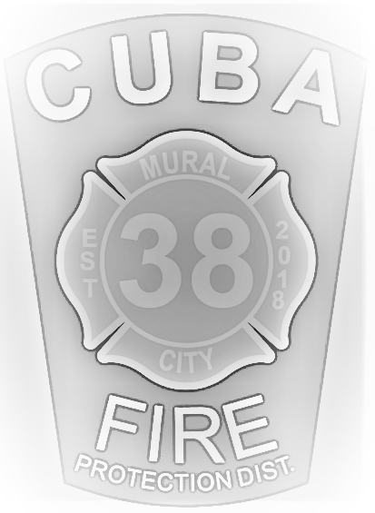
Check #___________________ Date:__________________________ Received By:_________________________________

