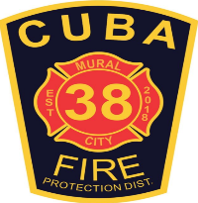
Cuba Community Fire Protection District
PO Box 511, 600 S Franklin Ave, Cuba, MO 65453
573-885-3366 | 573-885-0256Fax |www.cubamofire.com
Building Permit Application
Applicants are to fill out top section. Please submit a copy of any building plans when submitting application. Applicant will be responsible for contacting the Fire Marshal to inspect during construction, fire protection systems testing, and final inspection. The Cuba Fire Protection District has adopted the and follows the 2018 ICC Building and Fire codes. After plan review and permit fees are paid, a building permit will be issued. Any questions please contact the Fire Marshal.

Date of Application:_______________

Physical Address:____________________________________________ Business Name:________________________________________________

Property Owner:_______________________________ Property Owner Phone:___________________ Email:_______________________________

Contractor Name:__________________________ Contractor Address:_____________________________ Contractor Phone:__________________

Contractor Email:__________________________________ Proposed Work Type:_____________________________________________________

Building Use Group:________ Building Type:________ Width:_________ Length:________ Stories:_________ Est. Cost $:_____________________

____________ I acknowledge that I have read and unserstand all fees associated with the building inspection program of the Cuba Fire Protection District.

I hereby certify that the proposed work will abide by all applicable building and fire prevention codes enforced by the district and have been authorized by the owner of record to make the application as their authorized agent.

Signature of Owner

Approved By:___________________________________ Title:______________________________ Permit Fee:______________________________

Date Issued:_____________________________ Permit Number:____________________________

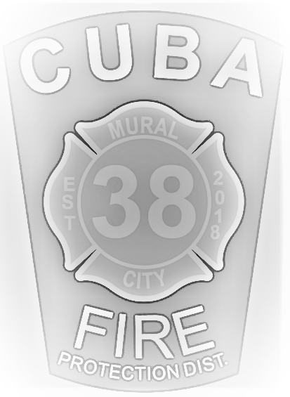
Check #___________________ Date:__________________________ Received By:_________________________________

